Practical Lab 1

1/ Create the database for students:

CREATE DATABASE DB_students;

**~~CREATE~~****~~DATABASE~~** ~~DB students;~~ //DB students

**~~CREATE~~** ~~DB DB_students;~~ //DATABASE

2/ Displays all databases stored in the server

**SHOW** **DATABASES**;

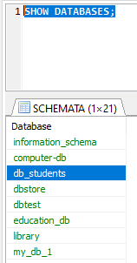

3/ In the future, we will create tables inside DB_students, so we to ...

USE DB_students;

4/ Create new table for departments

**create** **table** departments (

id_dept **int** **primary** **key**,

name_dept **varchar** (50)

);

5/ create new table for students

**create** **table** students (

id_student **int** **primary** **key**,

name **varchar**(50),

age **int**,

address **varchar**(100),

city **varchar**(30) **default** 'Afif',

id_department **int**

);

6/Display all tables in DB_students

**show** **tables**;

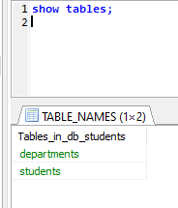

7/ Describe table students

**desc** students;

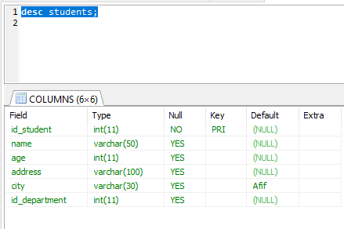

8/ add computer science department in the table department

**insert** **into** departments (id_dept, name_dept) **values** (1, 'Computer Science');

**~~insert~~****~~into~~** ~~departments (id_dept, name_dept)~~ **~~values~~** ~~('Computer Science', 2);~~

**~~insert~~****~~into~~** ~~departments (id_dept, name_dept)~~ **~~values~~** ~~(1, 'Computer Science');~~ // 1 primary key

**~~insert~~****~~into~~** ~~departments (id_dept, name_dept)~~ **~~values~~** ~~(2, 'Math', 'mathematical department');~~

9/ add Math and English department in the same SQL insert query

* Solution: multiple insert

**insert** **into** departments (id_dept, name_dept)

**values** (2, 'Math'), (3, 'English');

10/ Prb:

**~~insert~~****~~into~~** ~~departments (name_dept)~~

**~~values~~** ~~('Science');~~

* Solution: auto_increment

**create** **table** departments (

id_dept **int** **primary** **key** auto_increment,

name_dept **varchar** (50)

);

**create** **table** students (

id_student **int** **primary** **key** auto_increment,

name **varchar**(50),

age **int**,

address **varchar**(100),

city **varchar**(30) **default** 'Afif',

id_department **int**

);

11/ Display the content of table department

**select** * **from** departments;

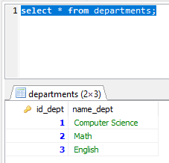

11/ Remove the English department

**delete** **from** departments **where** id_dept = 3;

12/ Modify the name of Computer Science to Computer

**update** departments **set** name_dept = 'Computer' **where** id_dept = 1;

**~~update~~** ~~table departments~~ **~~set~~** ~~name_dept = 'Computer'~~ **~~where~~** ~~id_dept = 1;~~

13/ delete all the content of the table department

**delete** **from** departments;